U2NESCO 2024 Invitation Letter

It is a pleasure to invite all schools to participate in the Tenth Annual U2NESCO Model United Nations Conference hosted by Utahloy International School Zengcheng. The conference will be held from January 18th to 20th, 2024. In this conference, we will have multiple English committees in which your students can participate. Something unique about the U2NESCO conference is that we will be providing a committee to promote the use of the Chinese language. In the Chinese Language Committee, all speaking, and resolution writing will be in Mandarin, which provides delegates who are more comfortable speaking in Mandarin with a chance to participate in this valuable experience. All topics for our 2024 conference will be built around the theme:

“The Future We Want”

U2NESCO was developed eleven years ago as a MUN conference for a wide range of delegates. It is perfect for both those first-time delegates, who would like to get their feet wet, to the more experienced delegate, looking for one of our ‘outstanding’ or ‘best’ delegate awards. If your school’s Model United Nations program would like to participate in our Ninth annual conference, please express your interest to the Secretary general, Katrina Lor, at 24klor@student.uiszc.org. More information can be found at www.u2nesco.com, which is where you can fill out your initial registration form as well as chair application form. We look forward to welcoming your delegates to our tenth U2NESCO Conference.

Best Wishes,

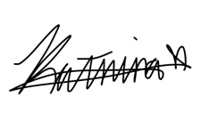
Katrina Lor
Secretary General
24klor@student.uiszc.org

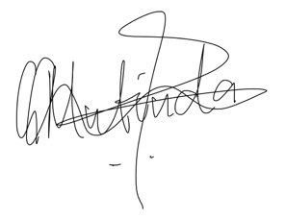
Gladys Ndunge Mutinda
MUN Director
gnm@uiszc.org

